

Marmara University
Electric-Electronic Engineering
Digital Design
CSE3017
Assignment 1
Prepared By
Sertan Aygün 150720822
Nurullah Said Tüğmen 150720823
Necati Şenel 150720521
In this assignment we will write verilog HDL code for D-latch circuit. D-latch circuit is given below.
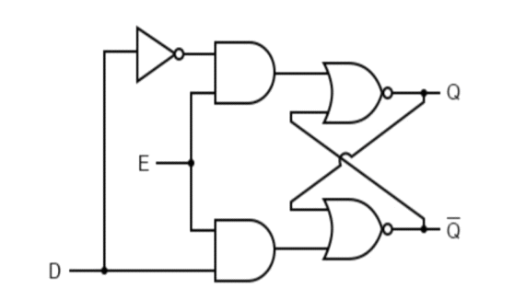
The truth table for this circuit is like this:
E | D | Q | Q’
0 | 0 | Latch | Latch
0 | 1 | Latch | Latch
1 | 0 | 0 | 1
1 | 1 | 1 | 0

Finally we can start to write verilog HDL code for this circuit:
Firstly I have started with writing codes for Gates
AND GATE VERİLOG HDL CODE:
module andGate(output c, input a, b);
assign c = a&b;
endmodule
NOT GATE VERİLOG HDL CODE:
module notGate(output a, input b);
assign a = ~b;
endmodule
NOR GATE VERİLOG HDL CODE:
module norGate(output c, input a, b);
assign c = ~(a|b);
endmodule
- Now let’s see the main code:
D-LATCH CIRCUIT VERİLOG HDL CODE:
module dLatch(output Q, cQ, input D, E);
wire a1, a2, b1;
notGate(a1, D);
andGate(a2, a1, E);
andGate(b1, D, E);
norGate(Q, a2, cQ);
norGate(cQ, b1, Q);
endmodule
Simulation (D-latch):
Also we tested and simulated this code on multisim:
For D = 0, E = 0
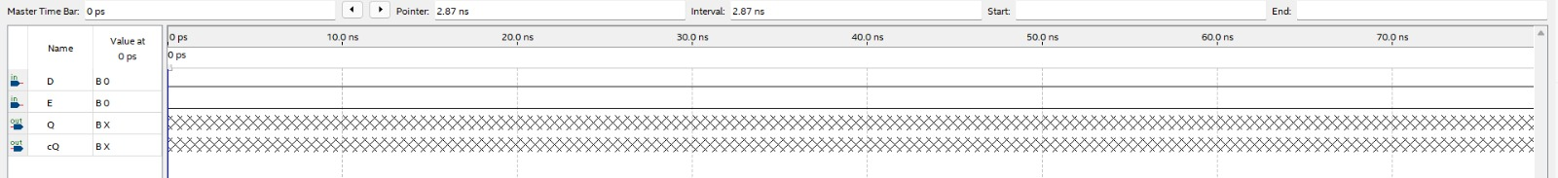

For D = 1, E = 0
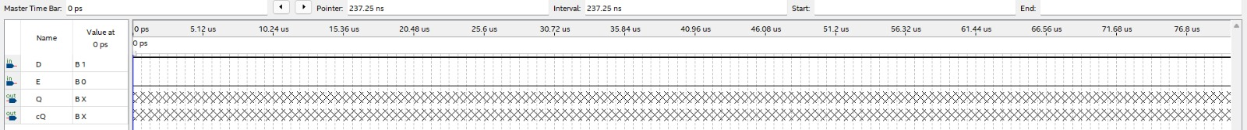
For D = 0, E = 1
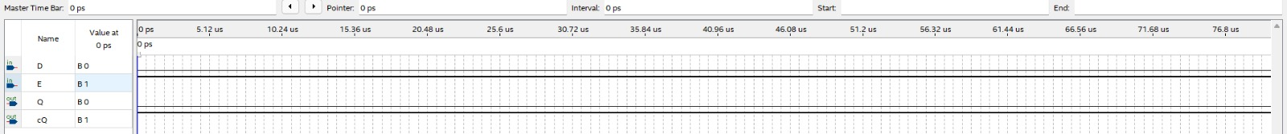
For D = 1, E = 1
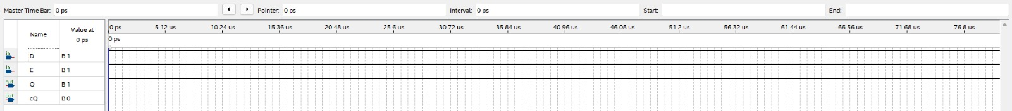
We also simulated this code via. D = 50% duty cycle 10 ns Period, E = 25% duty cycle 10 ns period signals.
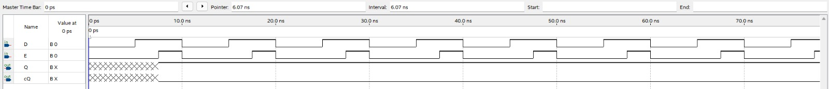
Simulation (And Gate):
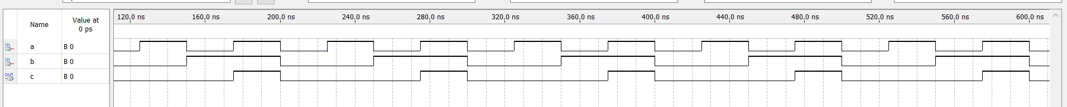
Simulation (Nor Gate):
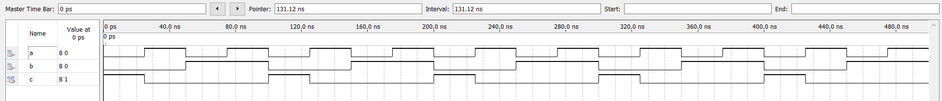
Simulation (Not Gate):


